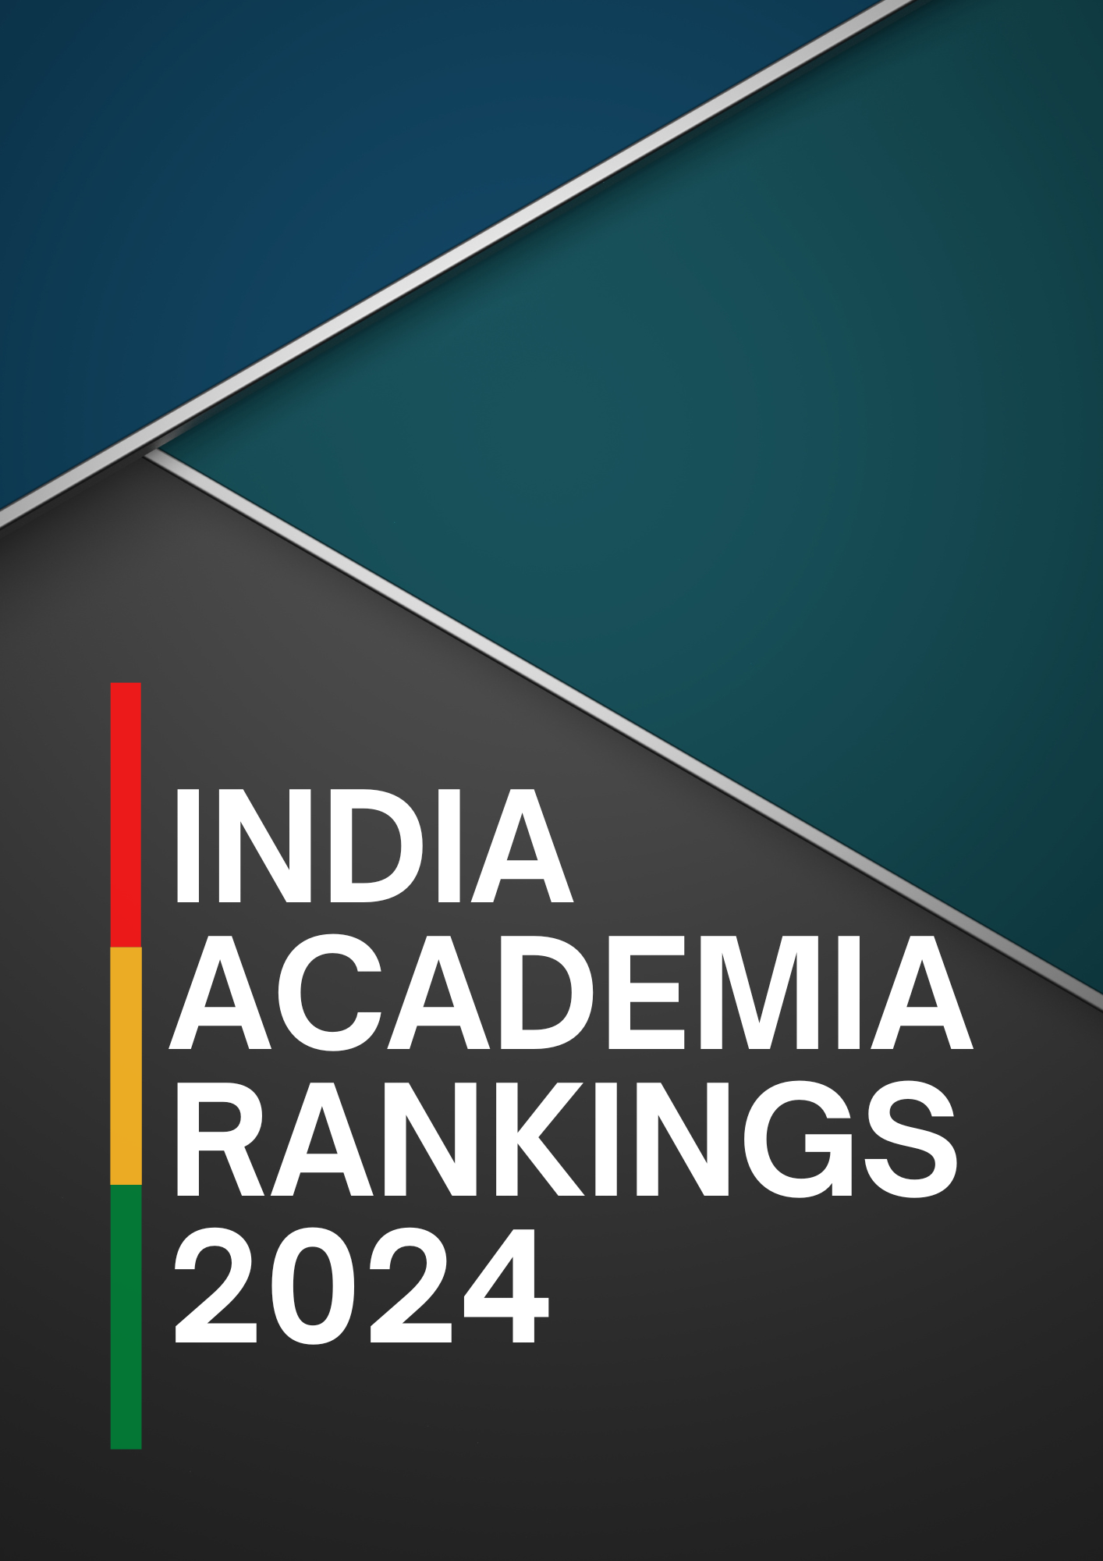

INSTITUTIONAL PROFILE

Primary Data of the HEI
Name of the HEI
Address
Website
Email ID

Date of Establishment
Accreditation / Ranking | AICTE | NBA |  | NAAC | AACSB |  | ABET |  | QS
Date of 1st Convocation |  |  |  | No. of Degree(s) Awarded
Total Number of Degree(s) Awarded  (Till August 2023) | UG |  | PG |  |  | Ph.D |  | PG Diploma

Name of the Chairperson
Designation
Email ID |  | Mobile -
Email ID (Secretary/PA) |  | Mobile -

Name of the Academic Head of HEI
Designation |  | Mobile -
Email ID |  | Mobile -

Student Strength
Total Number of Full-time Students on Rolls | UG |  | PG |  | Ph.D. |  | UG Diploma |  | PG Diploma
 | M | F | M | F | M | F | M | F | M | F
Total Number of Regular Academic Programs Offered (2022-2023) | UG |  |  |  | PG |  |  | Ph.D.

Teaching Faculty of the HEI
Full Time | Professor |  |  |  | Associate Professor |  |  |  | Assistant Professor
 | M | F | Others | Total | M | F | Others | Total | M | F | Others | Total

RESEARCH EXCELLENCE RANKING

RE1 : Does the HEI have an approved policy document for promotion of Research, including policy for use and upgradation of research-infrastructure, use of funds, awards and recognitions for research, contingency? [If Yes, attach the approval document, along with the policy].

RE2 : Number of research journal publications excluding conferences, (as verifiable from Web of Science/Scopus) of the faculty, staff, and/or students, independently at the Institute
Calendar Year | 2020 | 2021 | 2022 | 2023-24  30 Oct. 23
Publication

RE3: Number of research journal publications excluding conferences, (as verifiable from Web of Science/Scopus) jointly carried with contributions from external institutes/organizations
Calendar Year | 2020 | 2021 | 2022 | 2023-24  30 Oct. 23
Publication

RE4 : Number of Faculty/Staff (Student projects/grants not to be included) who have received any research projects/grants for research, from the State or Central Government agencies:
Academic Year | 2020-20 | 2021-22 | 2022-23 | 2023-24  30 Oct. 23
No. of Faculty
No. of Non-Teaching Staff, if any
Regional / National
International

RE5 : Amount of grants received for research/conference (Student projects/grants not to be included), from the State or Central Government Agencies:
Academic Year | 2020 (INR) | 2021(INR) | 2022 (INR) | 2023-24(INR)  30 Oct. 23
Regional / National
International Agency

RE6 : Number of Faculty/Staff (Student projects/grants not to be included) who have received any research projects/grants for research, from Private Organization/ Industry / NGOs
Academic Year | 2020-20 | 2021-22 | 2022-22 | 2023-24  30 Oct. 23
No. of Faculty
No. of Non-Teaching Staff, if any
Regional / National
International

RE7 : Amount of grants received for research/conference (Student projects/grants not to be included), from Private Organization/ Industry / NGOs:
Academic Year | 2020 (INR) | 2021(INR) | 2022 (INR) | 2023-24(INR)  30 Oct. 23
Regional / National
International Agency

RE8 : Does the HEI has availability and permits offering to access educational resources (labs, e-resources, library, computer system) to students/ people irrespective of their relationship with the college/institute. [If Yes, attach the approval document, along with the policy].

RE9 : Mention in less than 500 words, the Measure and tracking mechanism to check optimum usage of water, & ensure zero wastage.

RE10 : Strategic plans to upgrade existing infrastructure to higher energy efficiency buildings, and energy efficiency plan to reduce overall energy consumption.

RE11 : Policy and Strategic plan document to promote/implement 100% renewable energy and clean green energy technology.

RE12: Number of patents (Published and Granted) to the HEIs
Calendar Year | 2020 | 2021 | 2022 | 2023-24  30 Oct. 23
Published
Granted / Licenced

RE 13: Continuous Research in Learning and Developments : Academic Aspects
Describe the method of measuring the level of attainment of POs, PSOs and COs in not more than 500 words.
Total Number (with names) of specific courses (compulsory for all students, and not elective or optional) courses which address the Gender, Environment and Sustainability, Human Values and Professional Ethics | Attach Separate  Excel Sheets  (Attested by the Academic Head of the HEI)
Number of new short-term technology skill-based courses offered for across all programs offered during the last 2 years
Number of human-values and life-skills based courses offered for imparting transferable and life skills during the last 2 years
Percentage of students undertaking field projects / research projects / internships [ 2022-23 Passing out Batch Only] | Attach Program-wise Excel Sheet with No. of Students

RE 14: Explain in less than 1000words (with evidence) - A proven Best Practice in Research at the HEI.

EMPLOYABILITY AND STARTUP ECOSYSTEM RANKINGS (ESER)

ER1: Does the HEI have an approved Policy document to facilitate innovations, and to award for achievements. ? [If Yes, attach the approval document, along with the policy].

ER2: Attach in Separate Excel Sheet, Outreach events/education programs hosted by the institute to promote innovation, particularly for infrastructure and/or industry.

ER3: Attach a Policy document and evidence of implementation for incorporating any company at the Institute; and also showcasing the Establishment and operations for a full-fledged Innovation & Incubation Cell at the institute.

ER4: Income generated from Industries/Corporate/NGO, against Institute’s Intellectual Property Rights and by the Innovation & Incubation Cell.

Financial Year | 2020 | 2021 | 2022 | 2023-24  30 Oct. 23
Amount of Income generated

ER5: Internship, Placements and Student’s Progression

Average percentage of students qualifying in state/ national/ international level examinations during the last 5 years (eg: NET/SLET/GATE/GMAT/CAT/Civil Services/State government examinations) | 2022 –  2021 -  2020 -  2019-  2018-
Average percentage of placement of outgoing students during the last 5 years | 2022 –  2021 -  2020 -  2019-  2018-
Percentage of recently graduated students who have progressed to higher education [2021-2022 and 2022-2023 batch only] | 2022-  2021 -
Annual Package (CTC) of Placements of PG Students (i) Highest (ii) Lowest (iii) Average [2022-2023 batch only] | Highest-  Lowest -  Average -
Annual Package (CTC) of Placements of UG (B.Tech, B.Arch, Law, Design, Professional ) Students (i) Highest (ii) Lowest (iii) Average | Highest-  Lowest -  Average -
Annual Package (CTC) of Placements of UG (BBA, B.Com, BCA, B.Sc, BA) Students (i) Highest (ii) Lowest (iii) Average | Highest-  Lowest -  Average -
Number of International Companies Visited Campus for Recruitment/Placement Drive [2022-2023 batch only]
Number of Private - National Companies Visited Campus for Recruitment/Placement Drive [2022-2023 batch only]
Percentage of Students who have completed a minimum of 4 months paid internships [2022-2023 passing out batch only]
Number of Companies where in the students have completed their full-time paid internships [2022-2023 batch only]
Monthly Amount of Stipend / Internship paid per student [2022-2023 batch only] | Highest-  Lowest -  Average -

ER6: Entrepreneurship & Innovations
Total Carpet Area (in Sq. Ft.) for Co-Working Spaces
Total Carpet Area (in Sq. Ft.) dedicated for Entrepreneurship Cell (E Cell) /Innovation & Incubation Cell (IIC)
Total Numbers of Exclusive / Dedicated Employees (not shared staff) for Entrepreneurship Cell/Innovation & Incubation Cell (IIC)
Total Number of Start-ups / Companies Incubated in past 3 Years
Total Number of full-time jobs provided by those incubated startups
Total Number of Women Entrepreneurs created/supported by the established E-Cell/IIC in past 3 years
Total Number of full-time start-ups/organizations currently headquartered at the Institute & operational for regular business
Total Number of Events Organized by the Institute for E-Cell/IIC
Name and Verification details of the top 5 start-ups/companies incubated at the Institute
Name of the Company | Owner/ CEO/ CMD | Phone No | Website | Email ID of the CEO/CM/President
Total Number of Patents Filed by the Institute in past 5 Years [Academic Year Wise] |  |  |  | 2017-18:  2018-19:  2020-21:  2021-22:  2022-23:
Total Number of Patents Granted to the Institute / or its current faculty in past 5 Years [Academic Year Wise] |  |  |  | 2017-18:  2018-19:  2020-21:  2021-22:  2022-23:
Name and Contact Details of the Director/Chair Professor of  E-Cell/IIC |  |  |  | Name:  Designation:  Mobile:  Email ID:

PAYMENT DETAILS (FREE* , ZERO FEE FOR PREMIER PARTNER INSTITUTIONS)

Mode of Payment | NEFT/RTGS | ONLINE - DIRECT PAYMENT LINK
Date of Payment
UTR Number / Txn ID
ONLINE PAYMENT LINK | https://pages.razorpay.com/academia - Pay here!
Date of Membership Certificate for Premier Partner Institutions (Optional) | https://pages.razorpay.com/privilege – Get Annual Certificate

Undertaking and Declaration for Participation in the
India Academia Rankings 2023

I ……………………………………………………………(Name of the Head of institute), as the ……………………………….…. (Designation) certify that the information provided above is extracted from the records and to the best of my knowledge, is correct and complete. I understand that any false statement/information of consequence may lead to rejection. I also understand that the information submitted can be validated through direct/indirect means and the HEI/its officials will substantiate the facts with evidence..

Date: …………………… Place: ………………………

…………….……………………………….
Signature & Seal

